

SAFETY AND SECURITY

Building Features for Safety and Security

Safety and Security

Security Stations
The main Security station for the Mission Bernal Campus is located on the 2nd floor at the 27th Street Main Entrance / ED Entrance. Security enhancements include a metal detector at the Emergency Department entrance. Panic alarms are located in identified high risk areas; when activated, a silent alarm is sent to Security Dispatch. Security stations are located at key main entrances to include the ED, and Loading Dock. Security Dispatch phone number is 415-600-0837 (ext. 60837).

Crash Carts
In the event of a medical emergency for patients, visitors or staff, Crash Carts are strategically located throughout the Mission Bernal Campus.

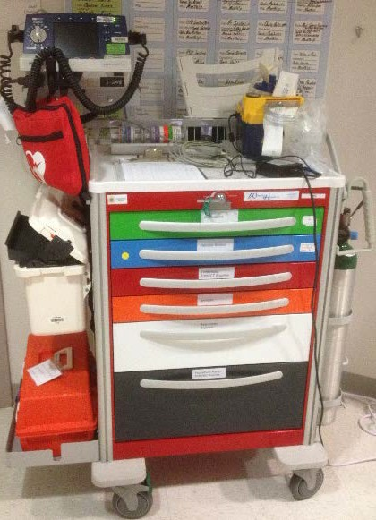
Figure 2: Typical Crash Cart
AED Stations
Tran – this is still pending; will be brief –locations and artwork; I will send under separate cover when received.

RESPONDING TO A CODE BLUE OR OTHER MEDICAL EMERGENCY

If you witness a patient, visitor or staff member who is in cardiac and/or respiratory distress, or having a medical emergency, immediately seek medical-nursing assistance by calling for help – and by dialing 5-5555 from a hospital phone. Patient Care areas should also use the Code Blue alarm system, but also need to alert the hospital Operator by dialing 5-5555.
For other types of urgent medical situations (Rapid Response) and non-medical emergencies (Code Red, Code Gray, etc.), dial 4-4444 from an in-house phone, provide nature of emergency, your name and location.

Code Team
The Code Team will respond to all patient medical emergencies in the main hospital and will respond to non-patient emergencies only if requested Code Blue is called. The Code Team is multi-disciplinary, made up of ICU MD’s, RN’s, Respiratory Therapist(s), Security, and a Nursing Supervisor.

Emergency Department (ED) Team
The ED team will respond to all non-patient emergencies in the main hospital.

Communications in a Disaster
The Sutter System affiliates use Everbridge Mass Notification System to communicate to all staff simultaneously in a disaster or other type of emergency situation. With a system-wide notification system, CPMC can ensure staff receive and respond to critical safety and business impact information in a timely manner.
Everbridge allows CPMC to communicate with employees via multiple contact paths including home phone, email, mobile phones and other communication devices during an emergency event.
What to do when a notification is received: Read (when received via email) or listen to the message carefully for directions; when asked to “confirm the message”, click on the link provided in the email, or “press 1” if the message is received via phone. The purpose of confirming the message is so that CPMC knows that you have received the message.
Everbridge has been implemented to improve the efficiency and effectiveness of communications.
Having accurate contact information is critical for Everbridge to work effectively and for you to receive emergency information. In some cases, personal contact information such as cell and home are inaccurate or missing in Lawson. Please check your personal profile to confirm the information is accurate and up to date.
How to update your personal contact information: Please ensure all of your personal contact information is up to date by checking the Lawson e-Self Service site on the Intranet Portal. Everbridge pulls from Lawson and unless your personal information is accurate you may not receive emergency notifications.
Questions regarding Everbridge should be directed to the Safety Department

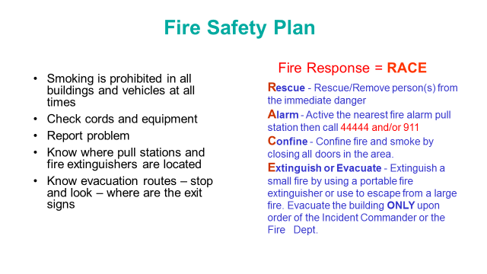

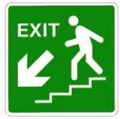
General Fire Safety
- During an actual fire or smoke event, do not use elevators. Follow exit signs to the nearest, safest exit stairwell.
- Do not open doors if they are hot to touch, or if you can see smoke. If you become trapped in a room, and cannot exit safety, keep the door closed and seal off any cracks. Call hospital operator at 4-4444 and report your exact location.
- If a door feels cool to the touch, open it cautiously. Be prepared to slam the door shut if the corridor is full of smoke or if you feel heat when opening the door. If the corridor is clear, proceed with evacuation.
- If you are caught in smoke or heat, stay low until you reach a safe area such another smoke compartment.

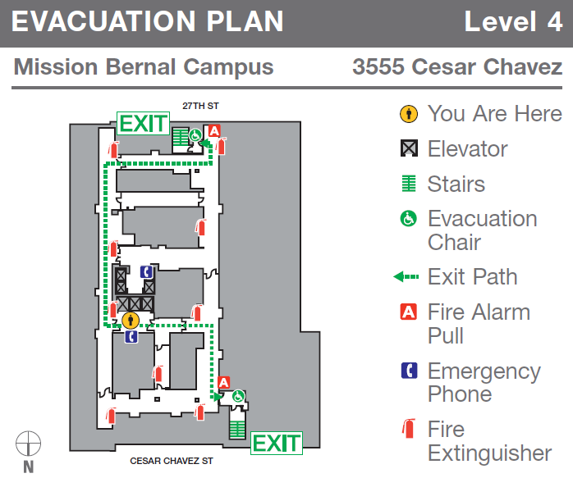
Evacuation Plan as shown below are located on each floor

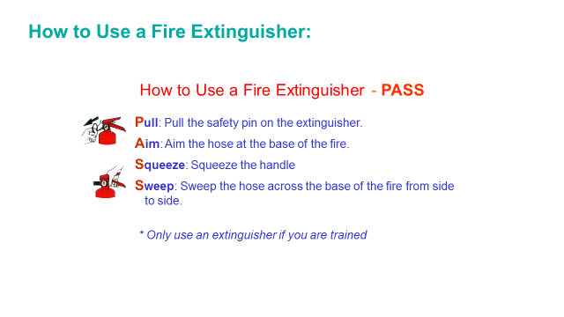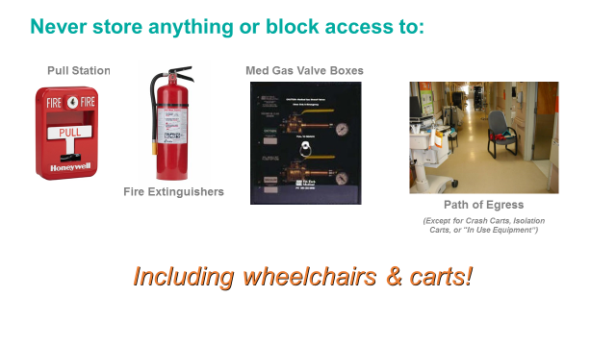

Emergency Operations Plan
Emergencies, disasters and other catastrophic events pose a significant threat to the ability of a healthcare organization to maintain operational capability and provide care, treatment, and services to its community.
California Pacific Medical Center (CPMC) has implemented a comprehensive all hazards Emergency Operations Plan in order to assure the most appropriate hospital response to the medical needs of the community, in the event of an emergency/disaster situation or a mass casualty incident. This is an organization-wide program that incorporates all services and sites of care under our license. This plan applies to staff, licensed independent practitioners, contract workers, volunteers and others as appropriate and indicated throughout this document.
This all hazards program complies with the elements of the National Incident Management System (NIMS) and incorporates the Hospital Incident Management System (HICS) and addresses the six critical areas mandated by Joint Commission standards. Those six critical areas are communications, resources and assets, safety and security, staff responsibilities, utilities management, and patient clinical and support activities.
The full plan is located on the CPMC Intranet

Hospital Command Center
The hospital uses the Hospital Incident Command Structure to manage emergency events and if the situation warrants the Emergency Operations Plan would be activated via Code Triage. If Code Triage is initiated, the Hospital Command Center (HCC) will be activated and is located on the First Floor, Conference Room A&B, if additional resources are needed to manage the event, the Labor Pool will be activated and is located in the hospital cafeteria.
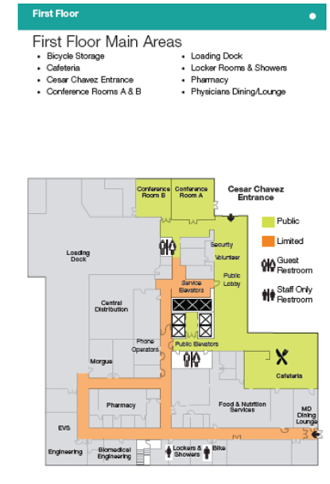

NEW STANDARDIZED EMERGENCY CODES
Emergency Code |  | Definition and Announcement
CODE BLUE  - Adult  - Maternity  - Pediatric  - V.A.D. | Cardiac or respiratory arrest  ANNOUNCEMENT: "Code Blue (Adult, Maternity, Neonate, Pediatric, or V.A.D.) - location"
CODE GRAY | Combative Person (aggressive, hostile, combative or potentially combative persons)  ANNOUNCEMENT: "Code Gray - location"
CODE ORANGE | Hazardous Material Spill/Release  ANNOUNCEMENT: "Code Orange - Hazardous Materials Spill/Release -  location"
CODE PINK | Infant Missing or Abducted (infants/children up to 2 years of age) ANNOUNCEMENT: "Code Pink last seen - location insert description (e.g. age, gender, race,) of missing infant and description (e.g. age, gender, race, clothing) of individual that may be with, if available."
CODE PURPLE | Child/Adult Missing or Abducted (child/adult over the age of 2) ANNOUNCEMENT: "Code Purple (child or adult) - last seen - location and description (e.g. age, gender, race, clothing)"
CODE RED | Fire  ANNOUNCEMENT: "Code Red - location"
CODE SILVER | Person with a Non-firearm Weapon and/or Hostage Situation ANNOUNCEMENT: "Code Silver - location. A security threat exists at location. All persons should immediately move away from that location if it is safe to do so. If it is not safe to move away, seek shelter or remain in a room with the door closed until an all clear has been announced."
Code Silver - ACTIVE SHOOTER | ANNOUNCEMENT: "Code Silver - active shooter - location. A security threat involving a firearm exists at location. All persons should immediately move away from that location if it is safe to do so. If it is not safe to move away, seek shelter or remain in a room with the door closed until an all clear has been announced."
CODE LIME | Electronic health record is down.  ANNOUNCEMENT: "Code Lime - initiate (EPIC, PACS, other) downtime procedures."
CODE SEPSIS | A patient is in septic shock and needs emergent attention. ANNOUNCEMENT: "Code Sepsis - location."
CODE TRIAGE, INTERNAL/ EXTERNAL ALERT/ ACTIVATE | Disaster/MCI/patient surge event. Activate Emergency Operations Plan for internal or external incident.  ANNOUNCEMENT: "Code Triage Internal/External – Alert – situation*." OR "Code Triage Internal/External – Activate – situation*. The emergency operations plan has been activated" When applicable the following should be added to the announcement: "Incident management team members should proceed to the location for a briefing."  *NOTE: Plain language should be used to describe the "situation." For
CODE YELLOW | Bomb Threat (a bomb threat or the discovery of a suspicious device or item) ANNOUNCEMENT: "Code Yellow - location."

Medical Alerts | Definition and Announcement
C-SECTION | A pregnant patient needs an emergent C-section. ANNOUNCEMENT: "Medical Alert: C-section - location."
ECMO | A patient needs emergent extracorporeal life support. ANNOUNCEMENT: "Medical Alert: ECMO (infant, child, or adult) - location."
IMMINENT DELIVERY | A pregnant patient in advanced stages of labor cannot be transported to the Labor & Delivery Unit prior to delivery and needs emergent attention. ANNOUNCEMENT: Medical Alert: Imminent Delivery - location."
MASSIVE BLOOD TRANSFUSION | A patient emergently needs a massive blood transfusion. ANNOUNCEMENT: "Medical Alert: Massive Blood Transfusion - location."

RAPID RESPONSE | A patient with early signs of clinical deterioration needs emergent attention to prevent respiratory or cardiac arrest.  ANNOUNCEMENT: "Medical Alert: Rapid Response - location."
SEPSIS | A patient has severe sepsis and needs urgent attention. ANNOUNCEMENT: "Medical Alert - Sepsis - location."
STEMI | A patient with myocardial infarction and ECG evidence of ST elevation needs emergent percutaneous coronary intervention.

What do you do if you get injured?
Employees are required to report all work-related injuries and/or illnesses to their supervisor or the on-duty supervisor immediately and complete an Electronic Report of Injury Form (eROI) by the end of shift in which the injury or illness occurred. The forms are located on the CPMC Intranet under Frequently Reviewed Forms – Environment of Care.
Upon completion and submission of the form, an incident analysis will be completed by the employee’s manager to determine what caused the incident and actions needed to be taken to prevent the incident from reoccurring.

Equipment and Furnishings

Ergonomics
Ergonomic chairs and keyboard trays are standard features of the new Mission Bernal Campus. The chairs and keyboard trays are fully adjustable.
For assistance on proper chair and keyboard adjustment, please contact Safety Management. They will send materials regarding self-assessments and if needed will direct you to complete the on-line ergonomic assessment.

ADA Information

Assistance for the Hearing, Listening, Visually and Speech Impaired

- MySutter Portal: Interpreter Services & Multilingual Resources http://mysutter/SHWBR/CPMC/Resources/MoreResources/Pages/InterpreterServices.aspx
- For American Sign Language Interpreter Services, (sign language only, not languages such Spanish, Chinese, etc.) To schedule an ASL interpreter
  - use the Online Interpreter Scheduling system or
  - call our ASL vendor at 1-800-975-8150

- For Assistive Listening Systems (Pocket Talkers), Call Campus Security at 415-600-0837 or ext. 60837
- For an Amplified Telephone Handset, call 74000 or 888-888-6044
- Closed caption decoders - Closed captioning is text that scrolls on a television screen so that an individual who cannot hear the content can read the text of the audio content. The televisions located in the [reception/visitor waiting areas, patient rooms] are equipped with Closed Caption features. The Closed Caption feature is available in every patient room and can be activated by pressing the Pillow Speaker “CC” button. Public areas where there are TV’s will be permanently set to have the Closed Caption feature on at all times.
- For a Braille, Large Print or audio format provider, call LightHouse for the Blind and Visually Impaired at 415-694-7358 (Braille) and 415-694-7312 (Audio) or by email at ais@lighthouse-sf.org.
ADA Service Animals

